

AP® Physics C
1993 Free response Questions

The materials included in these files are intended for use by AP teachers for course and exam preparation in the classroom; permission for any other use must be sought from the Advanced Placement Program®. Teachers may reproduce them, in whole or in part, in limited quantities, for face-to-face teaching purposes but may not mass distribute the materials, electronically or otherwise. These materials and any copies made of them may not be resold, and the copyright notices must be retained as they appear here. This permission does not apply to any third-party copyrights contained herein.

These materials were produced by Educational Testing Service® (ETS®), which develops and administers the examinations of the Advanced Placement
Program for the College Board. The College Board and Educational Testing Service (ETS) are dedicated to the principle of equal opportunity, and their
programs, services, and employment policies are guided by that principle.

The College Board is a national nonprofit membership association dedicated to preparing, inspiring, and connecting students to college and opportunity.
Founded in 1900, the association is composed of more than 4,200 schools, colleges, universities, and other educational organizations. Each year, the
College Board serves over three million students and their parents, 22,000 high schools, and 3,500 colleges, through major programs and services in
college admission, guidance, assessment, financial aid, enrollment, and teaching and learning. Among its best-known programs are the SAT®, the
PSAT/NMSQT®, and the Advanced Placement Program® (AP®). The College Board is committed to the principles of equity and
excellence, and that commitment is embodied in all of its programs, services, activities, and concerns.

APIEL is a trademark owned by the College Entrance Examination Board. PSAT/NMSQT is a registered trademark jointly owned by the College Entrance Examination Board and the National Merit Scholarship Corporation. Educational Testing Service and ETS are registered trademarks of Educational Testing Service.
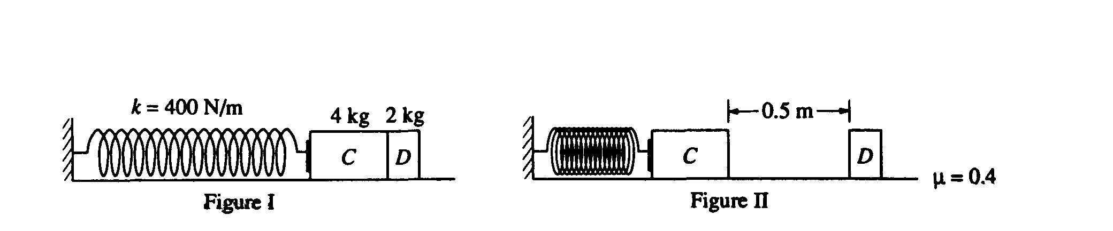
1993M1. A massless spring with force constant k = 400 newtons per meter is fastened at its left end to a vertical wall, as shown in Figure 1. Initially, block C (mass m_{c} = 4.0 kilograms) and block D (mass m_{D} = 2.0 kilograms) rest on a horizontal surface with block C in contact with the spring (but not compressing it) and with block D in contact with block C. Block C is then moved to the left, compressing the spring a distance of 0.50 meter, and held in place while block D remains at rest as shown in Figure 11. (Use g = 10 m/s².)
a. Determine the elastic energy stored in the compressed spring.

Block C is then released and accelerates to the right, toward block D. The surface is rough and the coefficient of friction between each block and the surface is μ = 0.4. The two blocks collide instantaneously, stick together, and move to the right. Remember that the spring is not attached to block C. Determine each of the following.
b. The speed v_{c} of block C just before it collides with block D
c. The speed v_{f} blocks C and D just after they collide
d. The horizontal distance the blocks move before coming to rest
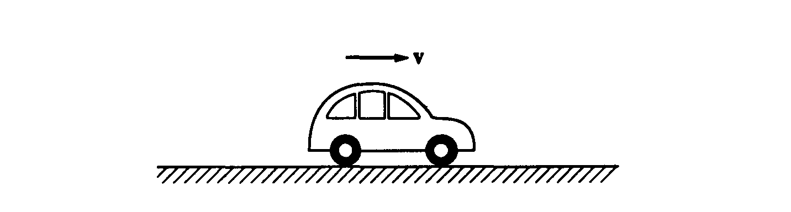
1993M2. A car of mass m, initially at rest at time t = 0, is driven to the right, as shown above, along a straight, horizontal road with the engine causing a constant force F_{o} to be applied. While moving, the car encounters a resistance force equal to -kv, where v is the velocity of the car and k is a positive constant.
a. The dot below represents the center of mass of the car. On this figure, draw and label vectors to represent all the forces acting on the car as it moves with a velocity v to the right.

b. Determine the horizontal acceleration of the car in terms of k, v, F_{o}, and m.
c. Derive the equation expressing the velocity of the car as a function of time t in terms of k, F_{o}, and m.

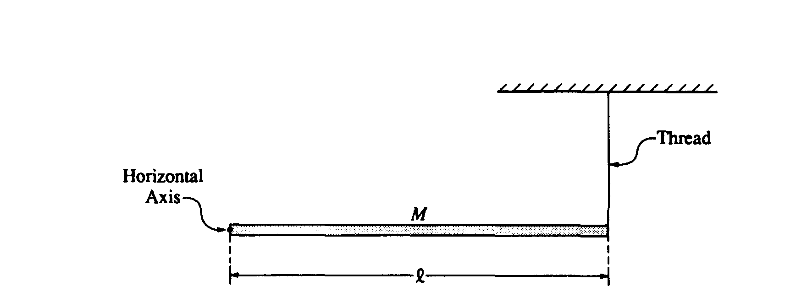
1993M3. A long, uniform rod of mass M and length l is supported at the left end by a horizontal axis into the page and perpendicular to the rod, as shown above. The right end is connected to the ceiling by a thin vertical thread so that the rod is horizontal. The moment of inertia of the rod about the axis at the end of the rod is Ml²/3. Express the answers to all parts of this question in terms of M, l, and g.
a. Determine the magnitude and direction of the force exerted on the rod by the axis.

The thread is then burned by a match. For the time immediately after the thread breaks, determine each of the following:
b. The angular acceleration of the rod about the axis
c. The translational acceleration of the center of mass of the rod
d. The force exerted on the end of the rod by the axis

The rod rotates about the axis and swings down from the horizontal position.
e. Determine the angular velocity of the rod as a function of θ, the arbitrary angle through which the rod has swung.
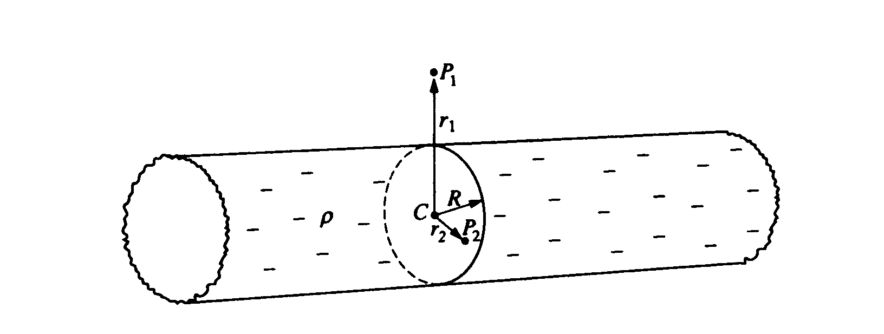
1993E1. The solid nonconducting cylinder of radius R shown above is very long. It contains a negative charge evenly distributed throughout the cylinder, with volume charge density ρ. Point P₁ is outside the cylinder at a distance r₁ from its center C and point P₂ is inside the cylinder at a distance r₂ from its center C. Both points are in the same plane, which is perpendicular to the axis of the cylinder.
a. On the following cross-sectional diagram, draw vectors to indicate the directions of the electric field at points P₁ and P₂.
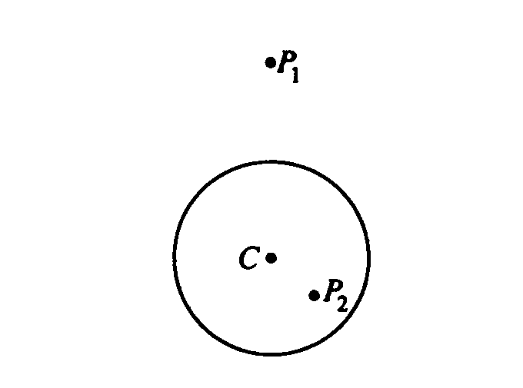
b. Using Gauss's law, derive expressions for the magnitude of the electric field E in terms of r, R. ρ, and fundamental constants for the following two cases.
i. r > R (outside the cylinder)
ii. r < R (inside the cylinder)

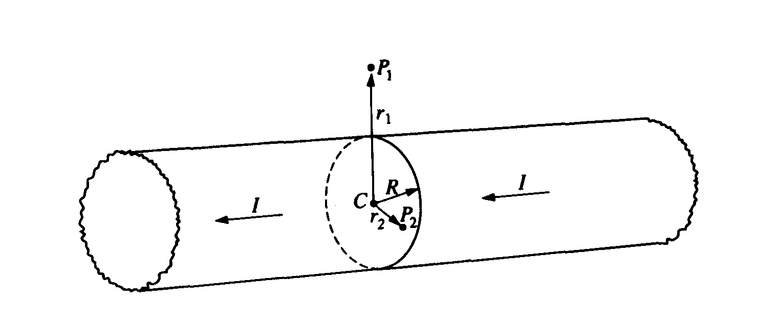
Another cylinder of the same dimensions, but made of conducting material, carries a total current I parallel to the length of the cylinder, as shown in the diagram above. The current density is uniform throughout the cross-sectional area of the cylinder. Points P₁ and P₂ are in the same positions with respect to the cylinder as they were for the nonconducting cylinder.
c. On the following cross-sectional diagram in which the current is out of the plane of the page (toward the reader), draw vectors to indicate the directions of the magnetic field at points P₁ and P₂.
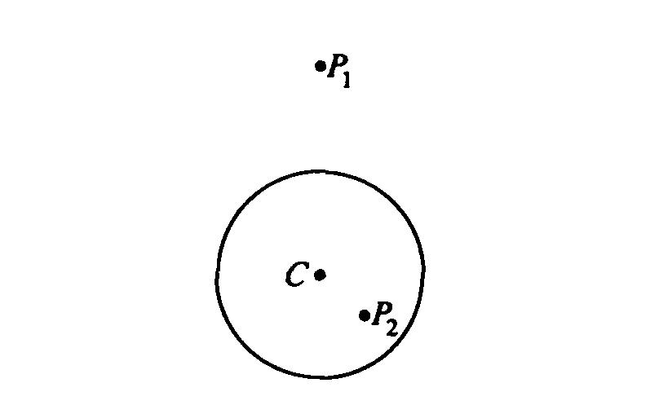
d. Use Ampere's law to derive an expression for the magnetic field B inside the cylinder in terms of r, R, I, and fundamental constants.
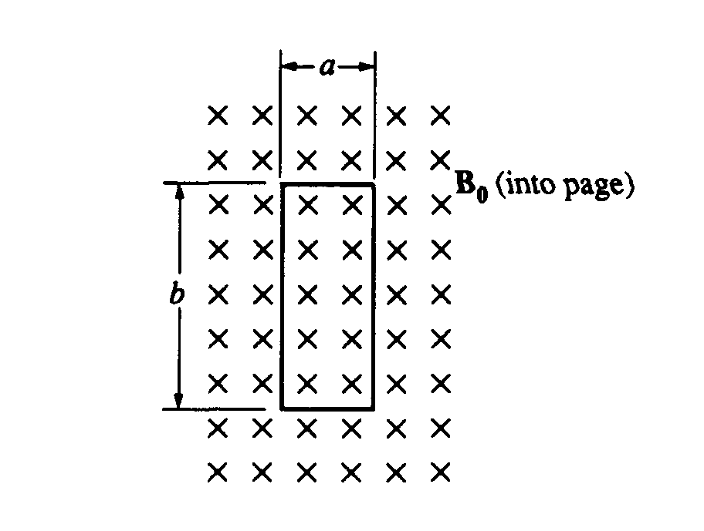
1993E2. A rectangular loop of copper wire of resistance R has width a and length b . The loop is stationary in a constant, uniform magnetic field B_{o}, directed into the page as shown above.
a. i. What is the net magnetic flux through the loop of wire?
ii. What is the induced emf in the loop of wire?
iii. What is the net magnetic force on the loop of wire?

Suppose instead that the uniform magnetic field varies with time t according to the relationship B = B_{o}cos(ωt), where ω, and B_{o} are positive constants and B is positive when the field is directed into the page.
b. Indicate on the diagram below the direction of the induced current in the loop when ωt = π/2, after the magnetic field begins to oscillate.
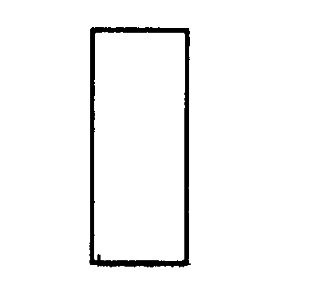
c. i. Derive the expression for the magnitude of the induced current in the loop as a function of time in
terms of a, b, B_{o}, R, t, and fundamental constants.
ii. On the axes below, sketch a graph of the induced current I versus ωt, taking clockwise current to
be positive.
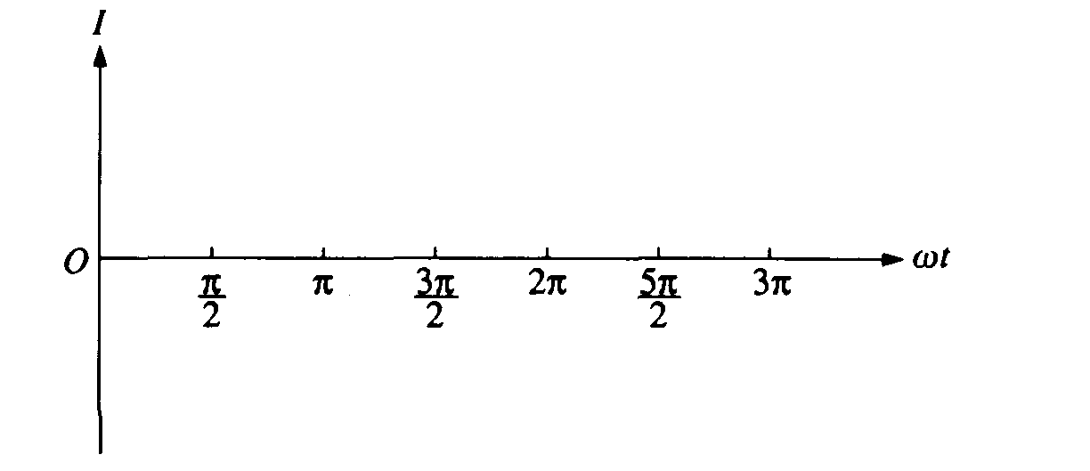
d. State explicitly the maximum value of the current I.

1993E3. A mass spectrometer, constructed as shown in the diagram above, is to be used for determining the mass of singly ionized positively charged ions. There is a uniform magnetic field B = 0.20 tesla perpendicular to the page in the shaded region of the diagram. A potential difference V = 1,500 volts is applied across the parallel plates L and K, which are separated by a distance d = 0.012 meter and which act as a velocity selector.
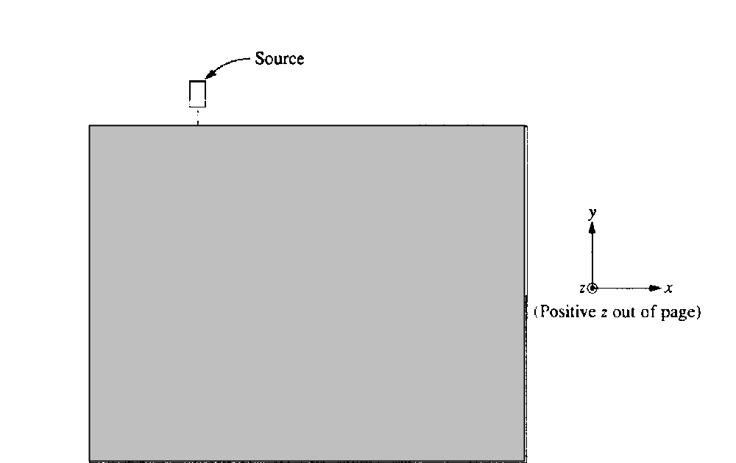

a. In which direction, relative to the coordinate system shown above on the right, should the magnetic field point in order for positive ions to move along the path shown by the dashed line in the diagram above?
b. Should plate K have a positive or negative voltage polarity with respect to plate L ?
c. Calculate the magnitude of the electric field between the plates.
d. Calculate the speed of a particle that can pass between the parallel plates without being deflected.
e. Calculate the mass of a hypothetical singly charged ion that travels in a semicircle of radius R = 0.50 meter.
f. A doubly ionized positive ion of the same mass and velocity as the singly charged ion enters the mass spectrometer. What is the radius of its path?

